EXPERIMENT 28
Implement Vehicle Detection Using OpenCV
Aim:
To detect and locate moving vehicles in each frame of a video using OpenCV.
Procedure:
- Import the OpenCV library.
- Read the input video.
- Apply background subtraction.
- Find moving objects using contours.
- Draw rectangles around sufficiently large moving regions.
- Display the detected regions in each video frame.
Program:
import cv2

cap = cv2.VideoCapture(r"D:\Amrita\Downloads\mixkit-cars-driving-by-on-road-2022-hd-ready.mp4")

bg = cv2.createBackgroundSubtractorMOG2()

while True:
ret, frame = cap.read()

if not ret:
break

mask = bg.apply(frame)

contours, _ = cv2.findContours(
mask, cv2.RETR_EXTERNAL,
cv2.CHAIN_APPROX_SIMPLE)

for c in contours:
x, y, w, h = cv2.boundingRect(c)

if cv2.contourArea(c) > 500:
cv2.rectangle(frame, (x,y),
(x+w,y+h), (0,255,0), 2)

cv2.imshow('Vehicle Detection', frame)

if cv2.waitKey(30) & 0xFF == ord('q'):
break

cap.release()
cv2.destroyAllWindows()

Input:
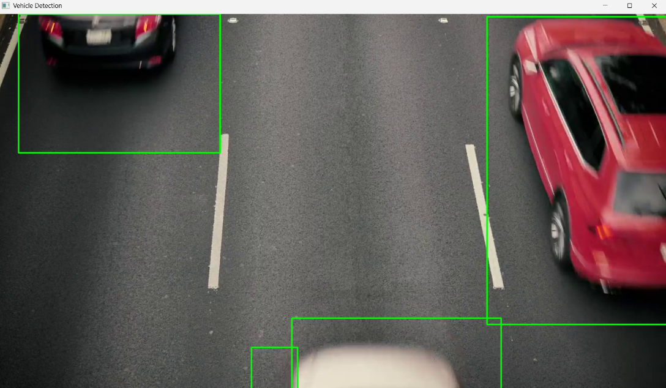
Output:
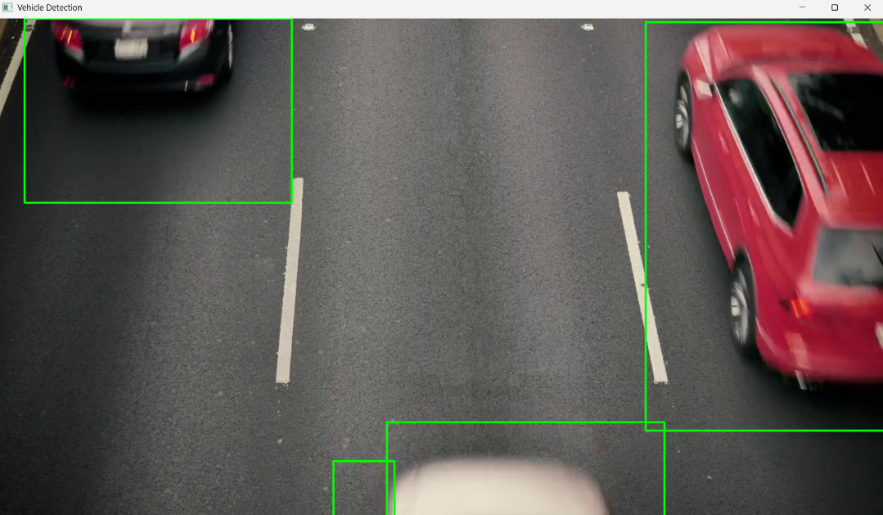
Result:
Thus, moving objects in the video were successfully detected and highlighted using OpenCV.

